|  |  |  |
| --- | --- | --- |
| **Online Food Corner** | | banner-bg.jpg |
|  | | |
|  | | |
| Submitted to:  Rida Mahmood Anmol Tariq Tooba Naseer 2016CE54 2016CE71 2016CE72  Sir Samyan Qayyum Wahla | | |
|  |  | |
|  | | |

Admin FrontEnd Screens:

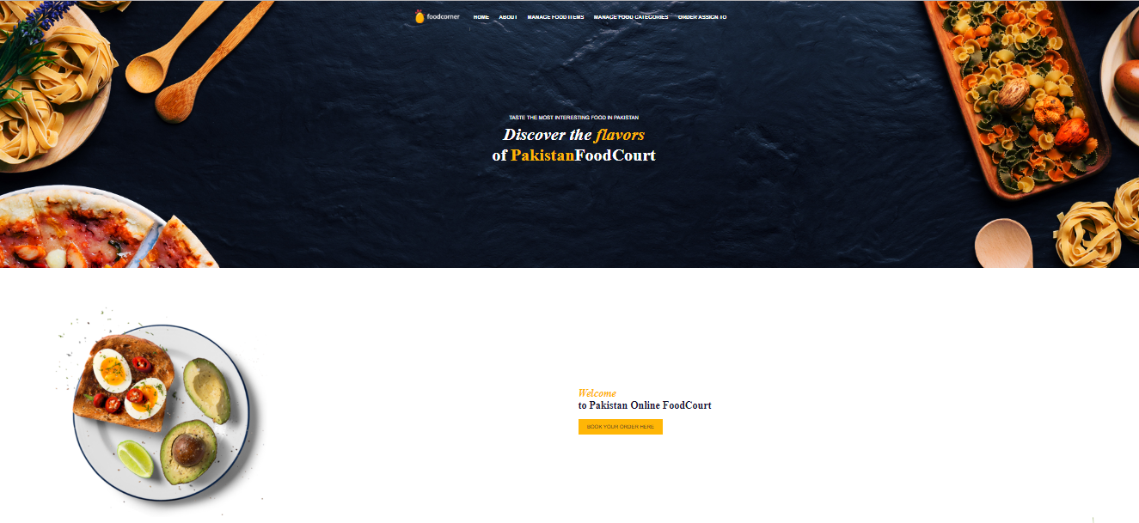

**1.Database used in that screen**

* Users
* Employees
* Designation

**2.From which screen, navigation of that screen is available**

If an employee type is an Admin, and signup his/her account, then he will be able to see this screen.

**3.Which actor is authorized to use that screen**

Admin

**4.Which feature is linked with that screen**

After Admin’s SignUp/LogIn, this is the screen of Homepage of Admin, from which he can manage food categories and food items, assign order to chef or deliverer.

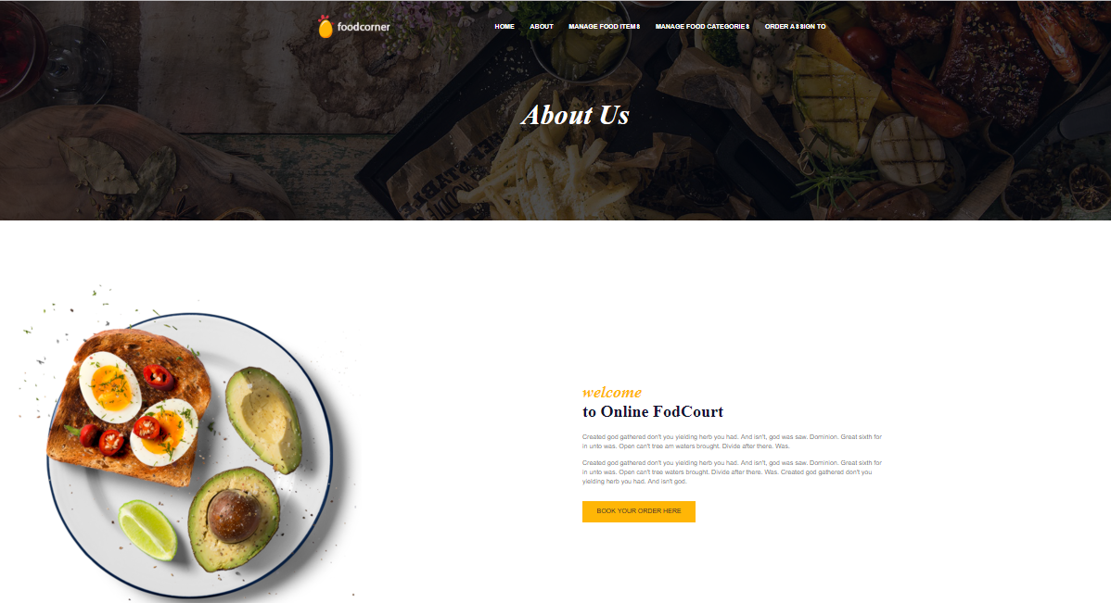

**1.Database used in the screen**

* Users
* Employees
* Designation

**2.From which screen, navigation of that screen is available**

If an employee type is an Admin, and signup his/her account, then he will be able to see this screen.

**3.Which actor is authorized to use that screen**

Admin

**4.Which feature is linked with that screen**

After Admin’s SignUp/LogIn, this is screen of Homepage of Admin, from whch he can see or edit the details of food corner.

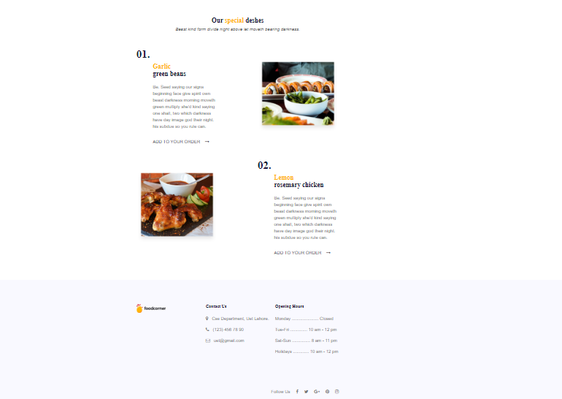

**1.Database used in that screen**

* MenuCard
* FoodCategory

**2.From which screen, navigation of that screen is available**

If an employee type is an Admin, and signup his/her account, then he will be able to see this screen.

**3.Which actor is authorized to use that screen**

Admin

**4.Which feature is linked with that screen**

After Admin’s SignUp/LogIn, this is screen of Homepage of Admin, from which he can manage food categories and food items, assign order to chef or deliverer.

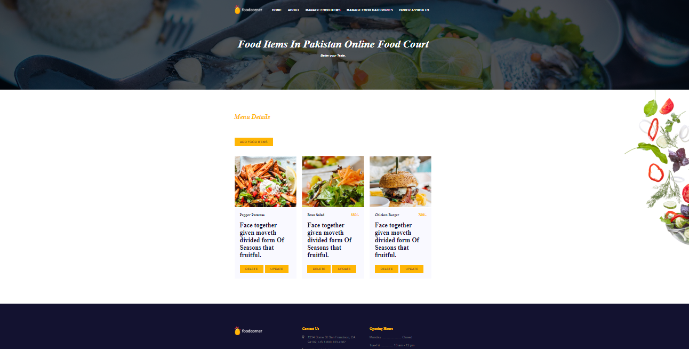

**1.Database used in that screen**

* MenuCard
* FoodCategory

**2.From which screen, navigation of that screen is available**

When an admin wants to add, change or delete fooditems from the menu then from His Homepage, he moves to this screen

**3.Which actor is authorized to use that screen**

Admin

**4.Which feature is linked with that screen**

From this screen, Admin of the foodcorner can add, update or delete the food items in the menu.

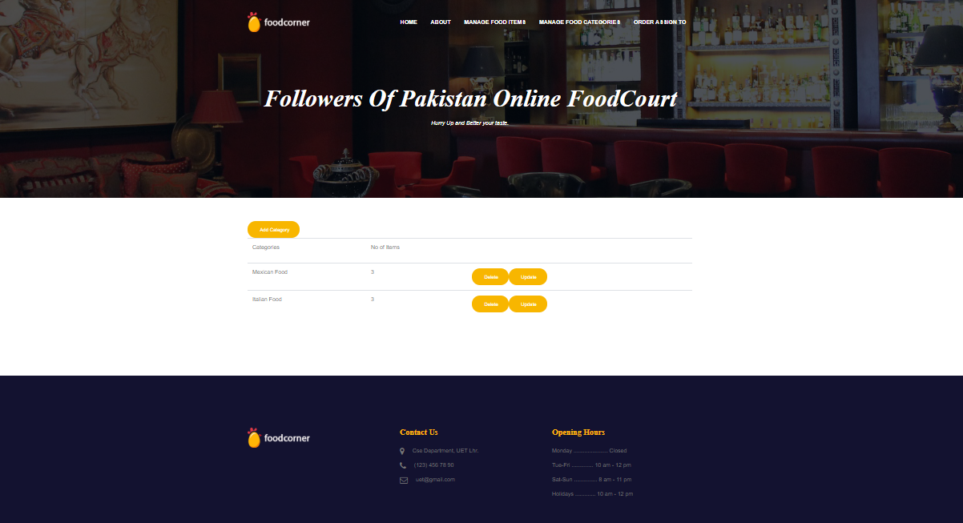

**1.Database used in that screen**

* MenuCard
* Employee(Admin)
* FoodCategory

**2.From which screen, navigation of that screen is available**

When an admin wants to add, change or delete food categories from the menu then from His Homepage, he moves to this screen

**3.Which actor is authorized to use that screen**

Admin

**4.Which feature is linked with that screen**

From this screen, Admin of the foodcorner can add, update or delete the food categories in the menu.

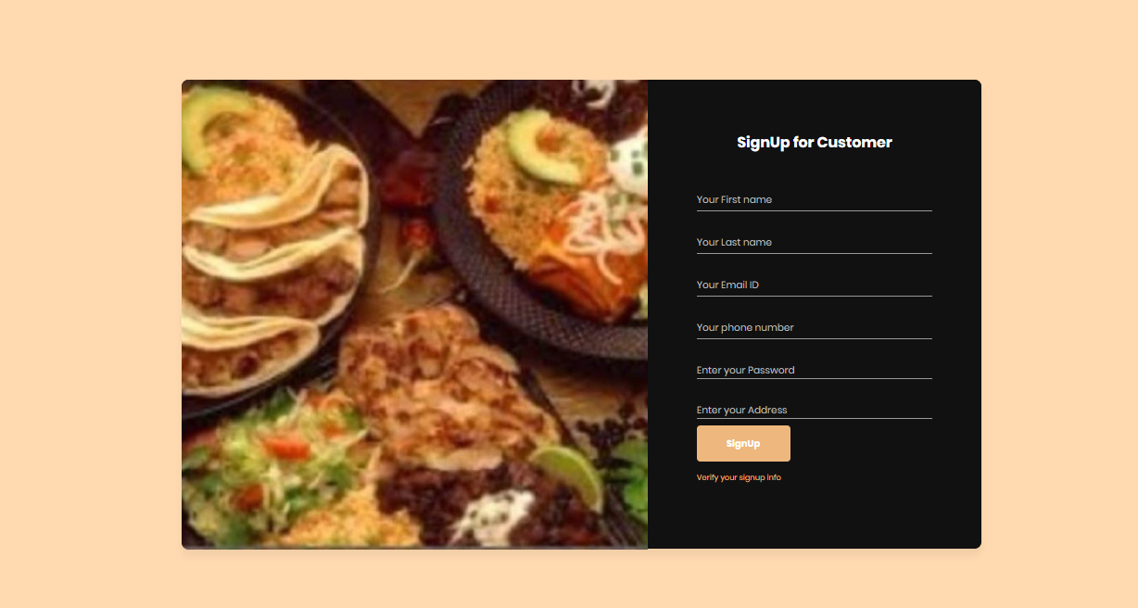

**1.Database used in that screen**

* Users
* Customers

**2.From which screen, navigation of that screen is available**

From main page of the WebApplication, when customer see advertise and wants order food, they must have to register themselves firstly.

**3.Which actor is authorized to use that screen**

Customer

**4.Which feature is linked with that screen**

SignUp of a Customer

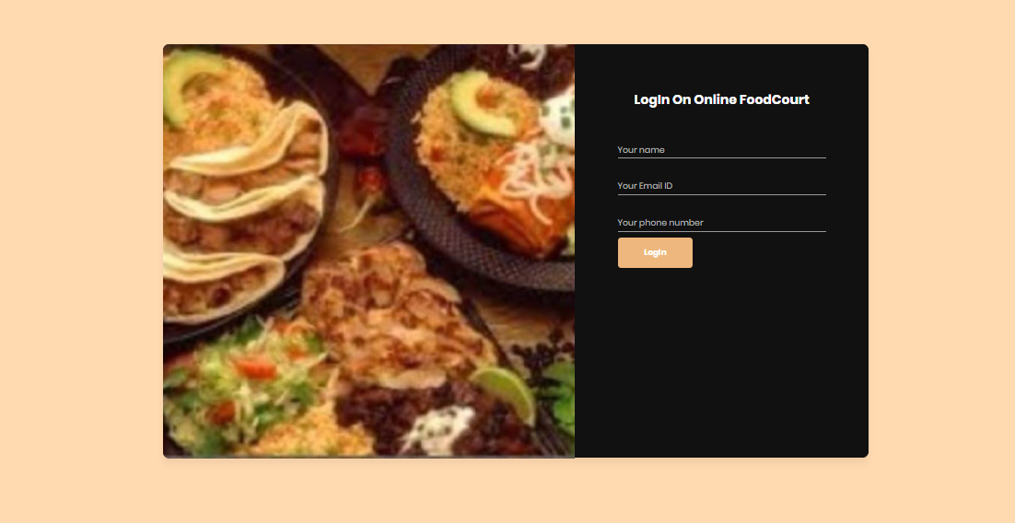

**1.Database used in that screen**

* Users
* Customers
* Employees

**2.From which screen, navigation of that screen is available**

From main page of the WebApplication, when customer wants to order food, they must have to login their account if it already exists.

**3.Which actor is authorized to use that screen**

Customer

**4.Which feature is linked with that screen**

LogIn of a Customer

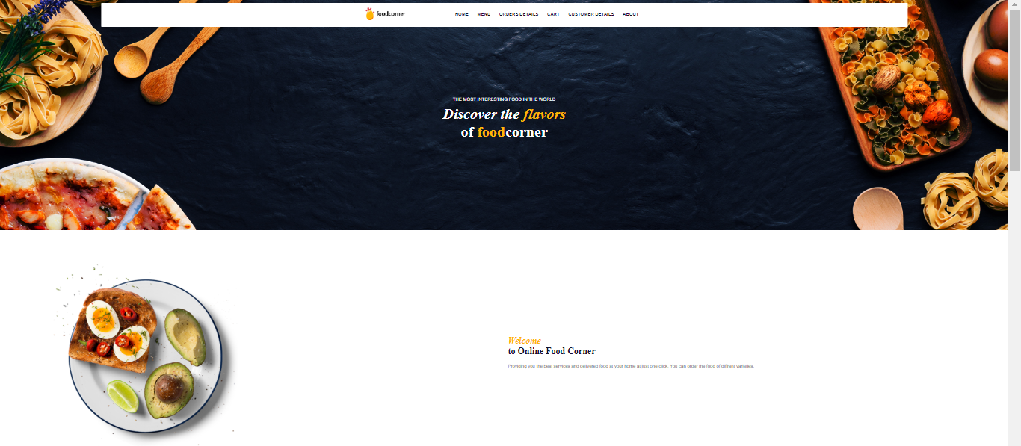

**1.Database used in that screen**

* Users
* Customers

**2.From which screen, navigation of that screen is available**

When a customer signup/ LogIn his/her account, then he will be able to see this screen.

**3.Which actor is authorized to use that screen**

Customers

**4.Which feature is linked with that screen**

From this webpage , Customers can order food , add or delete food items to/from cart in order to order the food, can see order details, can see their own profile by clicking respective buttons.

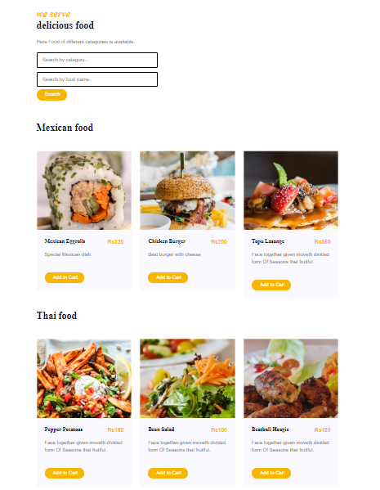

**1.Database used in that screen**

* Users
* Customers
* Orders
* Menu Card
* FoodCategory

**2.From which screen, navigation of that screen is available**

After SignUp/LogIn, customers can order food from this webpage.

**3.Which actor is authorized to use that screen**

Customers

**4.Which feature is linked with that screen**

From this screen, a customer can order food, add food items to cart,delete food items from cart, a customer can search food by category or by name for their ease.

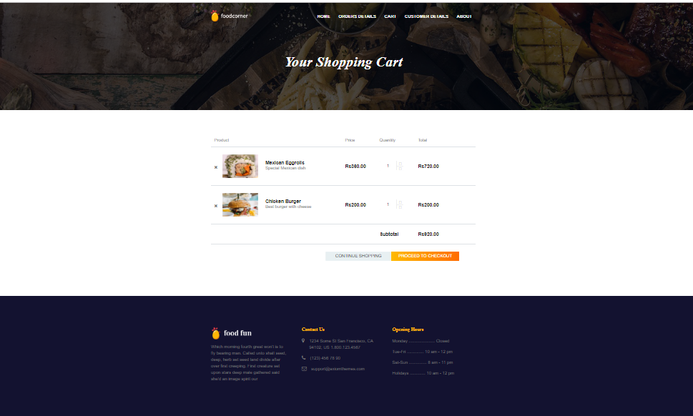

**1.Database used in that screen**

* Users
* Customers
* Orders
* PurchasedItems
* FoodCategory
* MenuCard
* OrderDetails

**2.From which screen, navigation of that screen is available**

When customer clicks on the button o homepage showing “Click here to order” , this screen appears.

**3.Which actor is authorized to use that screen**

Customer

**4.Which feature is linked with that screen**

Customers can see Product names, their prices , quantity of food they are ordering. They can also see total bill of their order. Customers can also add more fooditems to their cart they want to order.

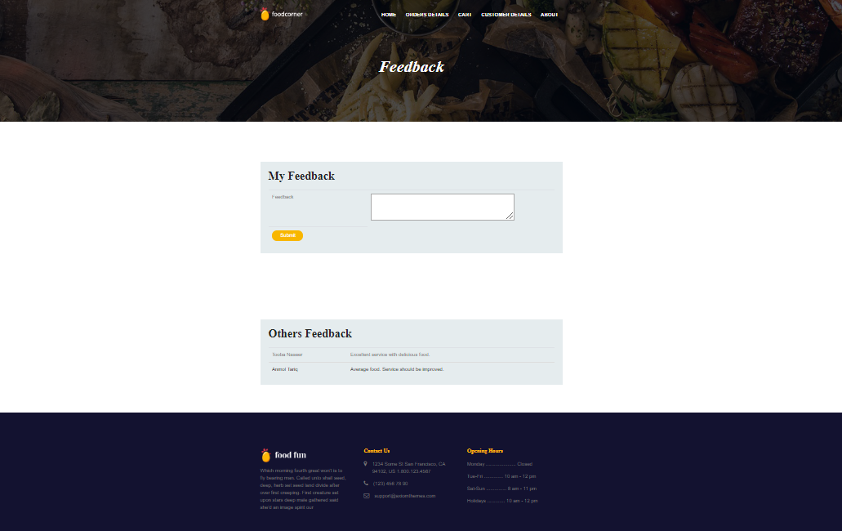

**1.Database used in that screen**

* Users
* Customers
* Feedback

**2.From which screen, navigation of that screen is available**

From homepage of customer, when customer wants to see his/her/other’s feedback for the foodcorner, he moves to this screen by clicking a button showing feedback.

**3.Which actor is authorized to use that screen**

Customer

**4.Which feature is linked with that screen**

Customers can see feedback of other people for the foodcorner or they can leave their own feedback here.

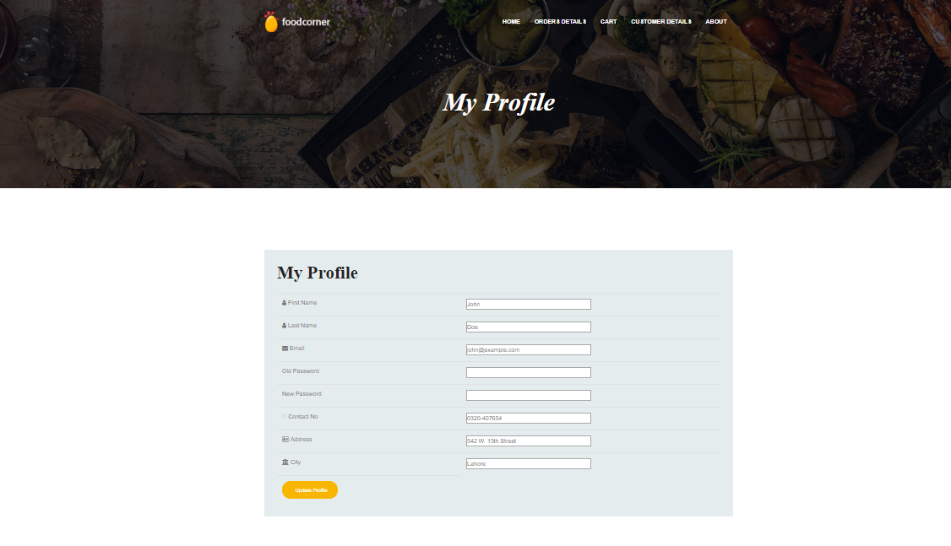

**1.Database used in that screen**

* Customers
* Users

**2.From which screen, navigation of that screen is available**

From customer’s home webpage, when they want to see or edit their profile information .

**3.Which actor is authorized to use that screen**

Customers

**4.Which feature is linked with that screen**The information associated with the customers, which is stored in database for further usage(ordering, login etc).

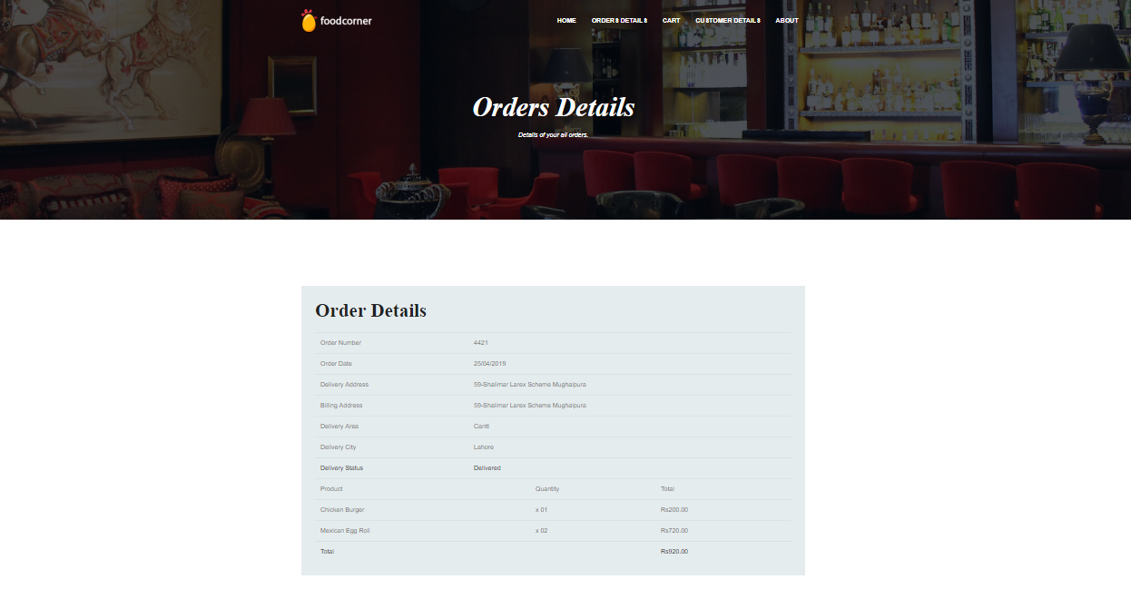

**1.Database used in that screen**

* Customers
* Orders
* OrderDetails
* Orders Delivery Teams
* TeamMembers
* MenuCard
* FoodCategory

**2.From which screen, navigation of that screen is available**

From customer’s homepage, when customers want to see their order details.

**3.Which actor is authorized to use that screen**

Admin

Customer

**4.Which feature is linked with that screen**

Customers can see their order status whether it is delivered or not, their order/billing address, their order’s other details i.e. ordered products, their prices etc.

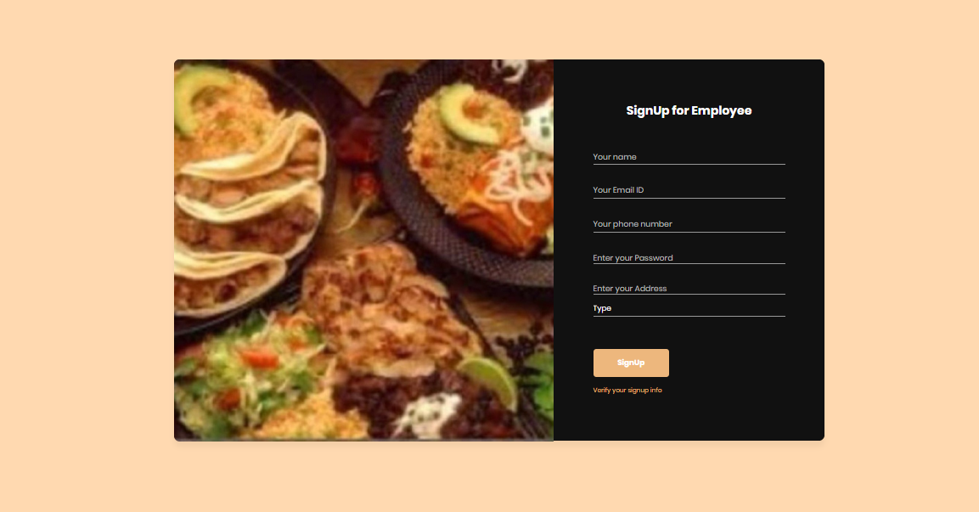

**1.Database used in that screen**

* Users
* Designation
* Employees

2.From which screen, navigation of that screen is available

From main page of the WebApplication, when a new employee(admin/chef/deliverer)wants to join foodcorner, he must have to register himself first.

**3.Which actor is authorized to use that screen**

Employees(Admin,Chef,Deliverer)

**4.Which feature is linked with that screen**

SignUp for Emloyees

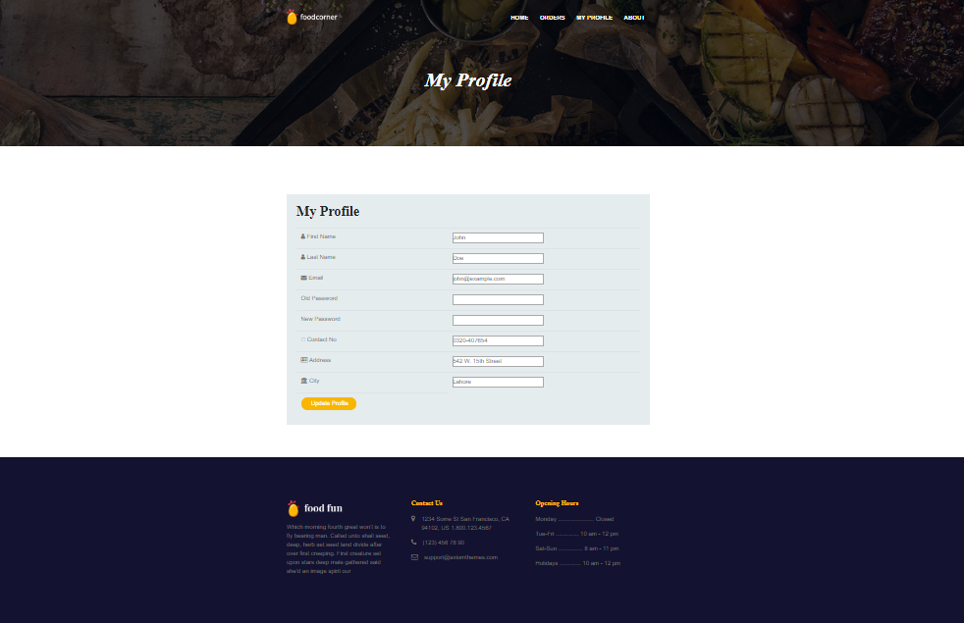

**1.Database used in that screen**

* Employees
* Users

**2.From which screen, navigation of that screen is available**

From Employee’s home webpage, when they want to see or edit their profile information .

**3.Which actor is authorized to use that screen**

Employees(Admin, Chef, Deliverer)

**4.Which feature is linked with that screen**

The information i.e. Address,Contact,Name,Password associated with employees, which is stored in database and can be edit by employees.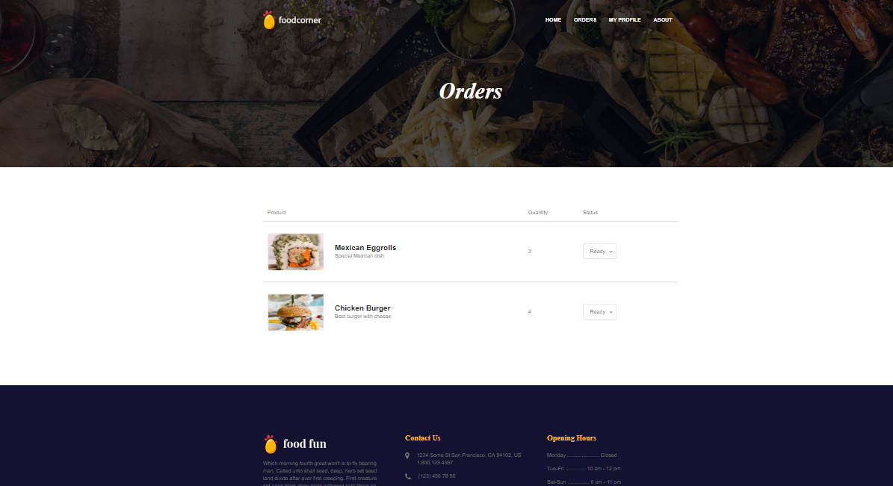

**1.Database used in that screen**

* Users
* Employees
* Designation
* ChefOrder
* EmployeeType
* OrderDetails
* MenuCard
* FoodCategory
* User
* Orders

**2.From which screen, navigation of that screen is available**

When an employee click on orders tab to show orders that assigned to him, this screen appears.

**3.Which actor is authorized to use that screen**

Chef

**4.Which feature is linked with that screen**

Through this screen, a chef can see the order details he have to made.

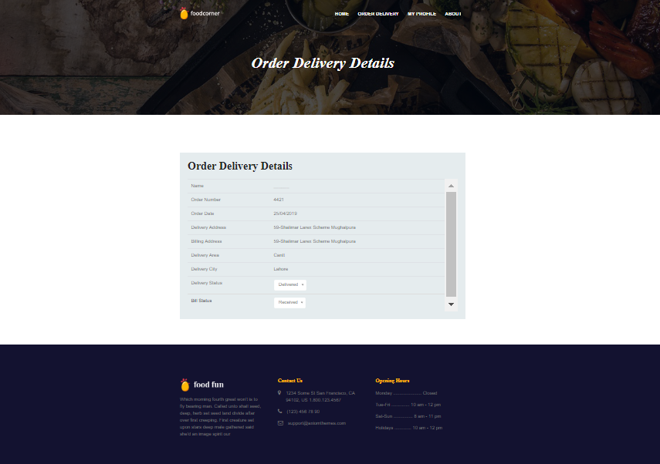

**1.Database used in that screen**

* Employees
* Users
* Designation
* Orders
* OrderDetails
* Suppliers
* PurchasedItems
* OrdersDeliveryTeam
* DeliveryTeam
* TeamMembers
* MenuCard
* FoorCategory

**2.From which screen, navigation of that screen is available**

When a deliverer clicks on the orders tab to see what orders assign to him, what he has to deliver to the customer, then this screen appears.

**3.Which actor is authorized to use that screen**

Deliverer

**4.Which feature is linked with that screen**

Through this screen, a deliverer can see the order delivery details i.e. where he has to deliver the order, from where he has to collect the bill of the order and has right to update the status of the order time by time whether it has delivered or not.

List of Funtionalities

|  |  |  |
| --- | --- | --- |
|  | FrontEnd | BackEnd |
| 2016CE54 | LogIn/SignUp/Half of Admin Dashboard | TeamMembers management, Customer management (Feedback of customers, profile info), users regiteration |
| 2016CE71 | Employees Dashboard/Remaining Admin | Food items(menu card) and food categories management, cheforders management, suppliers record |
| 2016CE72 | Customer Dashboard Complete | Orders management, delivery team management, employees management,purchased items record. |